WAVE AND VIBRATION W.S.

Refer to the following information for the next two questions.

A sine curve that represents a transverse wave is drawn below.

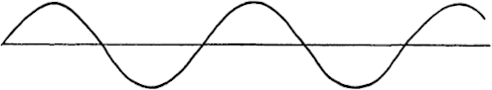

- Using the ruler provided, measure the wavelength of the wave.

- Using the ruler provided, measure the amplitude of the wave.

Refer to the following information for the next two questions.

A kid on a playground swing makes a complete to-and-fro swing each 2 seconds.

- The frequency of the swing is .

0.5 hz | 1.0 hz | 2.0 hz

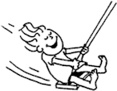
- The period of the swing is .

0.5  seconds | 1.0  seconds | 2.0  seconds

Refer to the following information for the next two questions
Complete each statement:
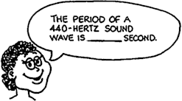
5.

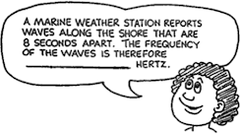

Refer to the following information for the next two questions.

6. The annoying sound from a mosquito is produced when it beats its wings at the average rate of 800 wing-beats per second.

- What is the frequency of the sound waves?

- What is the wavelength?

Refer to the following information for the next two questions.

7. A machine gun fires 20 rounds per second. The speed of the bullets is 300 m/s.

- What is the distance in the air between the flying bullets?

Refer to the following information for the next two questions.  8. Consider a wave generator that produces 20  pulses per second. The speed of the waves are 300cm/sec. | (b) What happens to the distance between the bullets if the rate of fire is increased?
  - What is the wavelength of the waves?

  - What happens to the wavelength if the frequency of pulses is increased?

decrease | remain the same | increase

Refer to the following information for the next two questions.

9. The bird at the right watches the waves. If the portion of a wave between 2 crests passes the pole each second.

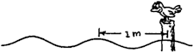
    - What is the speed of the wave?

    - What is its period?

- Suppose that the distance between crests in the above question were 2.0 meters apart and 2 crests pass the pole each second.
- What would be the speed of the wave?

- What would be its period?

Refer to the following diagram for the next three questions.

- When an automobile moves toward a listener, the sound of its horn seems .

relatively louder at a higher frequency
relatively softer at a higher frequency
relatively louder at a lower frequency
relatively softer at a lower frequency

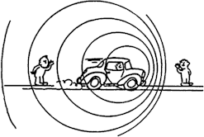
- When moving away from the listener, its horn seems .

relatively louder at a higher frequency
relatively softer at a higher frequency
relatively louder at a lower frequency
relatively softer at a lower frequency

- The Doppler Effect is due to changes in .

wave frequency | wave speed

- For a pendulum swinging in simple harmonic motion (small arcs), what positions of the swing correspond to the amplitude of the sine curve that describes the motion?
- If a mass oscillating on a spring is give more energy by a driving force, how does this affect the (a) amplitude, (b) frequency, and (c) period of the oscillation? Explain.

- If an object oscillates with a frequency of 10 Hz, how long does it take to make one complete cycle?

- Suppose it takes you 20 minutes to walk around the block twice.

  - What would be the period of your motion?

  - What would be your frequency in hertz? (What does this mean?)

- A mass oscillates with a frequency of 5 Hz. How many cycles does it go through in .

  - 2 seconds (b)0.6 seconds
- Radio station frequencies (radio waves) are in the kHz and MHz (kilohertz and megahertz) ranges. What are the corresponding ranges of the periods of these radio waves? (The speed of electromagnetic radio-waves are 3 X 10⁸ m/s).
- To maintain a steady-state oscillation, how much work must be done by the driving force? What happens if more or less than this amount of work is done?
- Give some examples in which damped harmonic motion is undesirable and some in which such is desirable.

- An automobile has springs and shock absorbers to provide a smooth ride. Explain how they smooth the ride.
- How does a bottle or twig bobbing up and down in a lake demonstrate that waves carry energy?

- After a motor boat passes by on a lake, an observer on the shore notices that the waves hit the shore every 2 seconds and that the distance between the crests of the waves is about 2 m. What is the speed of the water waves? Does this depend on the speed of the boat? Explain.

- When a motor boat moves across a lake, water waves continually lap the shore for some time after it has passed. But few or no waves reach the shore from a row boat. Why is this?

- In general, the wave speed in a medium is fixed by the elasticity and particle mass of the medium. With the wave speed constant in water, how is the distance between the crests of the surface waves affected when the disturbance frequency is increased.

- Light waves in vacuum travel at a speed of 300,000,000 m/s. The frequency of visible light is on the order of 10¹⁴ Hz (on followed by 14 zeroes). What is the order of magnitude of the wavelength of visible light?

- Sine curves representing two waves are shown below:

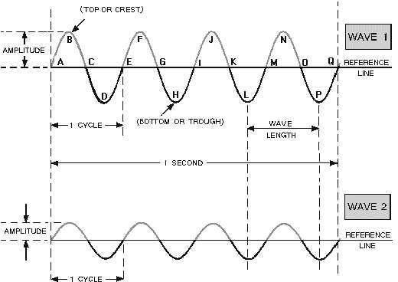

Which wave has the greater .

  - Amplitude,
  - Frequency,
  - Wavelength,
  - Period,

- The wave velocities of some transverse and longitudinal waves are in the upward direction. What are the oscillation directions of the waves?

- How would the intensity you receive from a point source vary if you .

- moved four times as fare from the source?

- moved two thirds of the distance closer to the source?

(Note: Intensity is Power/Area and Area is the surface area of a growing sphere or 4 ²)

- Two waves of equal amplitude interfere. What can you say about the amplitude of the combined wave form when the waves are .

- in phase

- out of phase

- completely out of phase

- Is energy destroyed in destructive interference? Explain. What is “destroyed”?

- Explain why interference patterns are formed; that is what causes a pattern?

- When a stretched ropes is oscillated at its fourth harmonic frequency, how many standing wavelengths are formed in the rope?
- A long, limber rod is clamped at one end, leaving the other end free. The boundary conditions for a standing wave in the rod are a nod and an antinode at the respective ends. In this case, only the od harmonics are possible, e.g. f0, 3f0, 5f0, and so on. Draw a few possible standing wave forms and demonstrate this in terms of wavelength.

The one-shaped shock wave produced by a supersonic aircraft is actually the result of overlapping spherical waves of sound, as indicated by the overlapping circles in this physlet animation. Sketches a, b, c, d, and e, below show an "animated" growth of only one of the many spherical sound waves (shown as an expanding circle in the two-dimensional sketch). The circle originates when the aircraft is in the position shown in a. Sketch b shows both the growth of the circle and position of the aircraft at a later time. Still later times are shown in c, d, and e. Note that the circle grows and the aircraft moves farther to the right. Note also that the aircraft is moving farther than the sound wave. This is because the aircraft is moving faster than sound.
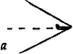
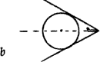
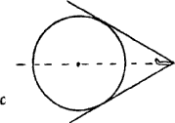
Careful examination will reveal how fast the aircraft is moving compared to the speed of sound. Sketch e shows that in the same time the sound travels from 0 to A, the aircraft has traveled from 0 to B, twice as far. You can check this with a ruler.

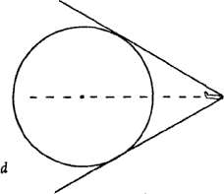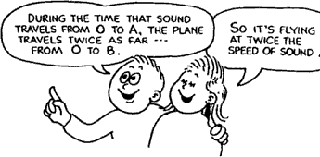
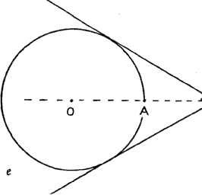
- Inspect sketches b and d. Has the aircraft traveled twice as far as sound in the same time in these positions also?

yes | no

- For greater speeds, the angle of the shock wave would be .

wider | the same | narrower

Refer to the following information for the next two questions.

39. Use a ruler to estimate the speeds of the aircraft that produce the shock waves in the two sketches below.

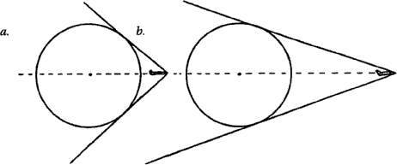
Aircraft 3a is traveling about times the speed of sound.

Aircraft 3b is traveling about times the speed of sound.

- Draw your own circle (anywhere) and estimate the speed of the aircraft to produce the shock wave shown below.
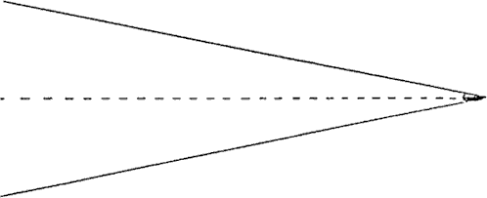

The speed is about times the speed of sound.
41. REVIEW: Refer to the following information for the next four questions.

In an experiment, liquid 1 is at room temperature (21ºC) and liquid 2 has been heated until it is warmer than room temperature. A student takes equal amounts of liquid 1 and liquid 2 and mixes them together in a beaker.

  - Compare the initial temperatures of liquid 1 and liquid 2 with the temperature of the mixture in the beaker at each of the following times:

- 5 minutes after mixing

- 2 hours after mixing

  - . Describe the transfer of heat energy between the two liquids in the beaker.

  - Identify one other possible heat energy transfer in this experiment.
42. REVIEW: A heated rock is placed in a container of water that is cooler than room temperature. Which of the following statements best describes what happens?

A. Cold is removed from the container of water until the rock, the container, and the water all reach the same final temperature.
B. The heated rock loses heat to the container of water until the rock, the container, and the water all reach the same final temperature.
C. The heated rock loses heat to the container of water until the rock, the container, and the water each reach a different final temperature.
D. Cold is removed from the container of water until the rock, the container, and the water each reach a final temperature lower than their original temperatures.

